

Instruction Manual
BUILT-IN FRIDGE, FREEZER & COMBI
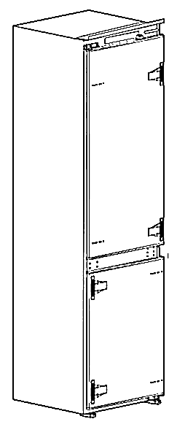
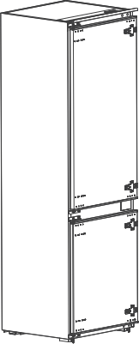

COMBI MODEL: COMBI MODEL：
CC266INT CC400INT

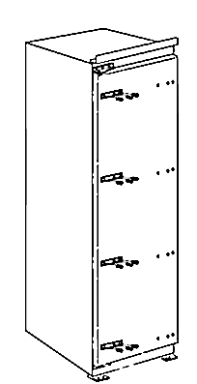
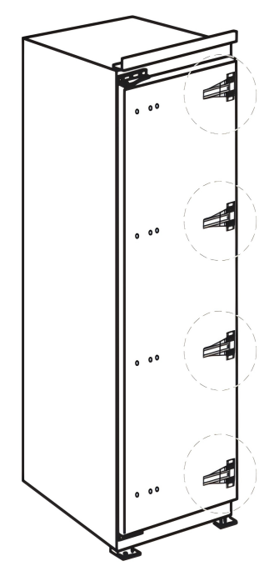

UPRIGHT FRIDGE: UPRIGHT FREEZER:
CF304INT CZ212INT


SCAN FOR INSTALLATION SERVICE
Attention: ANGOLA, KENYA, NIGERIA, TANZANIA & UGANDA
Installation is free of charge: Contact us for your free installation
Danger! Do not install by yourself: Self-installation voids the warranty. The manufacturer is not responsible for any accidents arising from self-installation



Congratulations on choosing a Newmatic Built-in Refrigeration Unit. Designed in Singapore, Newmatic appliances are trendy, durable & energy saving. They are manufactured with processes that respect the environment. Please continue this effort by ensuring that the packaging is disposed of in a responsible manner.

CONTENTS

- SAFETY INFORMATION
- CC266INT
- CC400INT
- CF304INT
- CZ212INT
- USING THE FRIDGE & FREEZER
- WARNINGS
- CARE & MAINTENANCE
- WARRANTY & SUPPORT

1. Safety information

General Safety
- Domestic use only. Using this appliance for commercial purposes voids the warranty
- Keep children supervised. Danger of electrocution or being trapped inside the compartment
- Do not store flammable materials
- Airtight containers especially of glass containing liquids must not be stored in the freezer compartment

Electrical Safety
- Plug into a grounded outlet
- Do not use extension cords or share the socket
- Disconnect the power before cleaning, maintenance or repair
- Damaged power chords should be replaced by the authorized technicians

Disposal
- Refrigerant and cyclopentane foaming material used for the refrigerator are flammable. When the refrigerator is scrapped, it shall be kept away from any fire source and be recovered by a special recycling company to protect the environment.
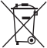
- When the fridge is disposed, cut off the electrical cord, disassemble doors and gaskets so as the prevent trapping any child
Correct Disposal of this product
This symbol indicates that the product must not be disposed of with regular household waste. To protect the environment and human health, please recycle it responsibly. You can return the product to local collection points or contact the retailer where it was purchased. They will ensure the product is recycled safely and in an environmentally friendly way.

2. CC266INT

2.1 CC266INT PRODUCT OVERVIEW
Fridge section

LED lighting

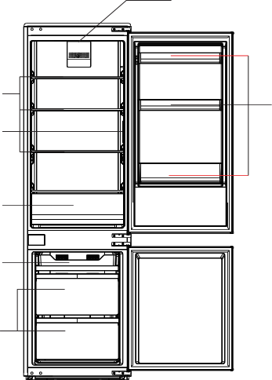

Shelf
Door
tray
Temperature control panel

Fruits and
vegetables box

Storage box

Drawer
CC266INT

Freezer section
2.2 CC266INT – Cabinet Preparation
min. 50
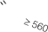


570+0
H ≥1785+A
4
1773
H+4

696+A

Cabinet
vent > 200cm2
A- thickness
of cabinet plank

Front view
Side view
CC266INT

2.3 CC266INT – Installation

1.Push the refrigerator into the cabinet and adjust it to make sure the edgefold of top baffle completely touches the top edge of the cabinet, and the limit hook The supporting leg completely touches the bottom edge of the cabinet.
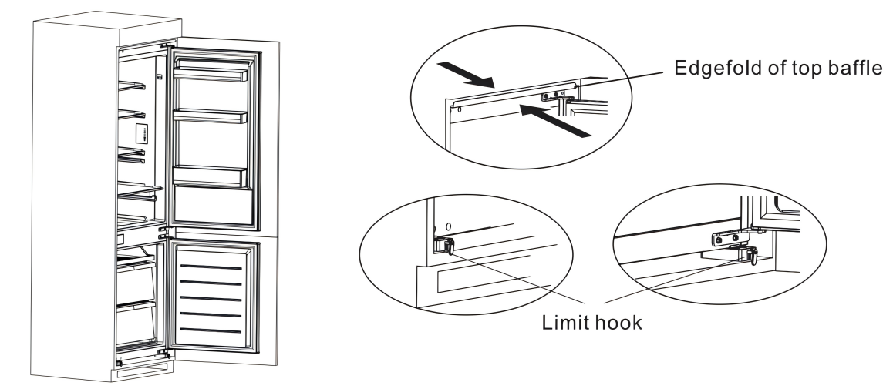

2.Fix the supporting leg with screws, then install the screw caps.

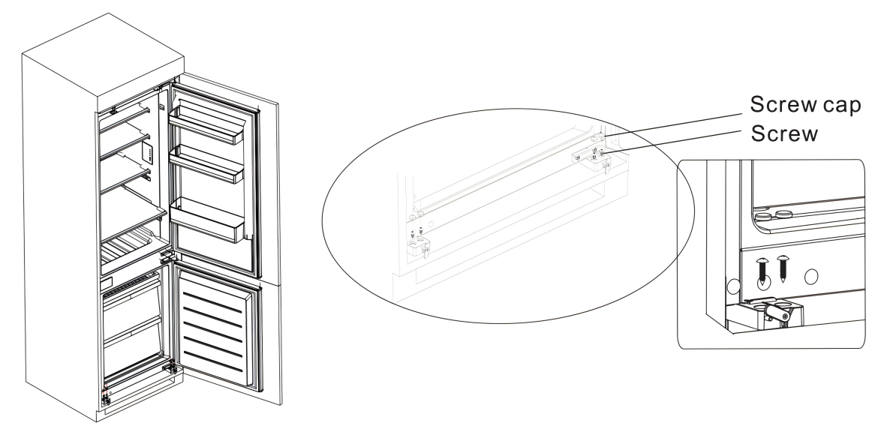

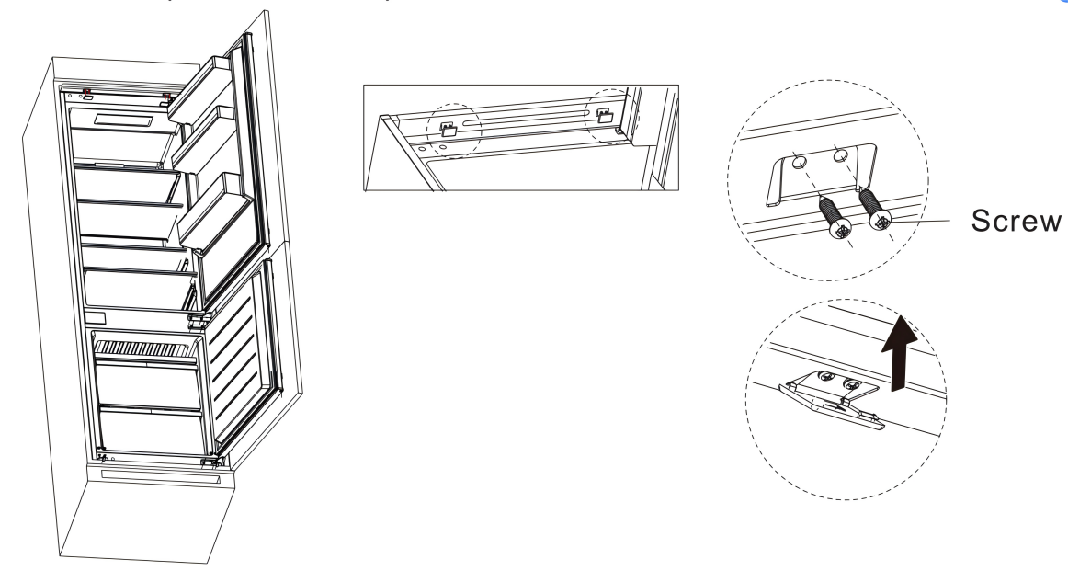
- Fix the top baffle to the top of the cabinet inner with screws, then install the screw caps.

4.Open the lower door of the cabinet to the maximum angle, and open the lower door of the refrigerator to the corresponding position. Slide the block to make sure the inner edge aligns with the lower door edge of the refrigerator, then fix the block to the door of the cabinet with a screw and install screw caps. Fix the upper refrigerator door to the cabinet door in the same way.
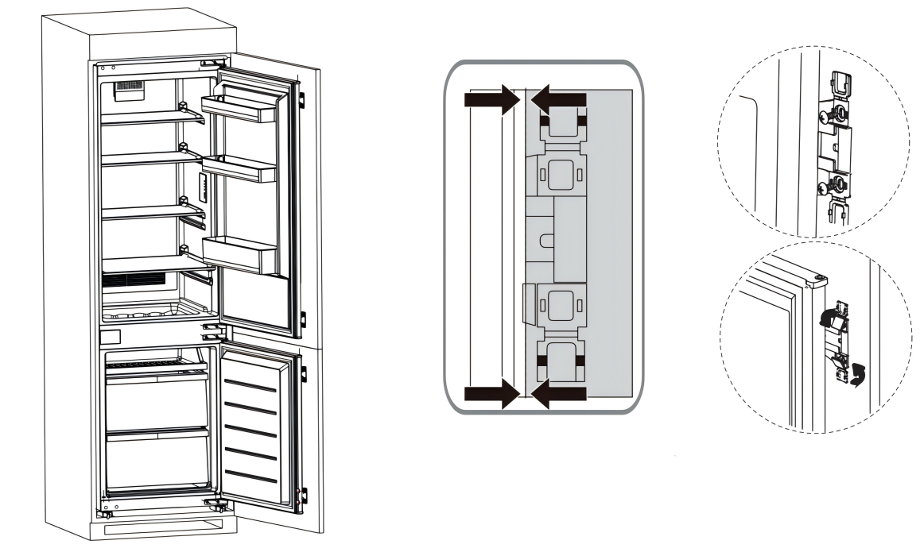

CC266INT

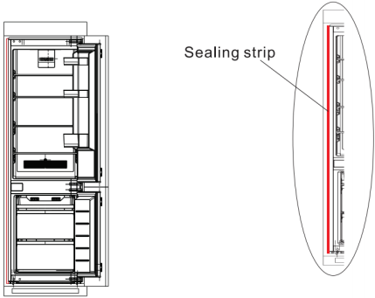

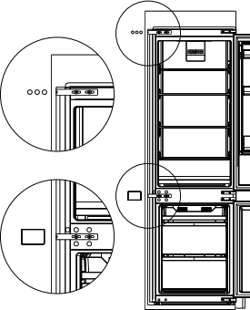
5.Remove the decorative cover on the left side of the beam. Take out the fixing block, screws, and plastic inserts from the accessory bag. Insert the plastic inserts into the upper (or lower) holes of the middle beam and attach the fixing block to the opposite holes with screws. Half-tighten the screws, move the block toward the cabinet, then fully tighten. Finally, secure it to the cabinet with the small screws. (This step is optional.)
.
CC266INT

2.4 CC266INT – Changing Door Direction

2.3 Door Right-Left Change

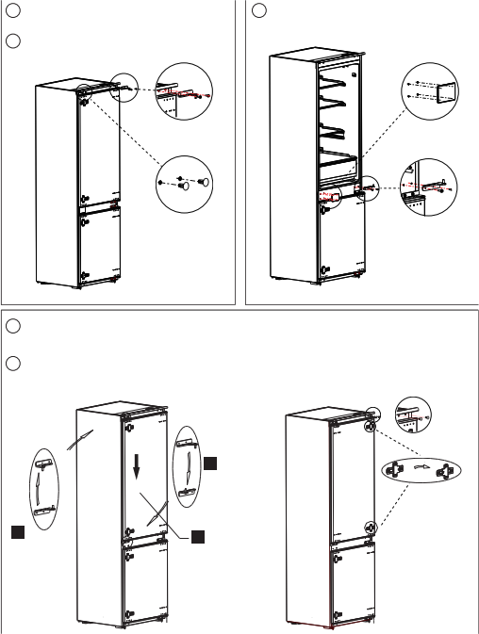
Power off the refrigerator, and remove all objects from the door trays.
Remove the upper hinge and hole caps of refrigerator door.
1

2
3 Remove the refrigerator door, the
bottom hinge and the hole caps.

Upper hinge Hole cover

Hole caps R:
bottom hinge

4 Exchange the R:bottom hinge and R:upper hinge ,then install them according to below steps, and install the top hole caps.
5 Remove the two fixed blocks of refrigerator door and rotate them for 180°, and install them on other side of refrigerator door.
CC266INT

R:
bottom hinge
Fixed block
Install left
upper hinge
180
Put the
refrigerator
door of left
bottom hinge vertically.
Hole caps
R:
upper hinge
Install left
bottom hinge

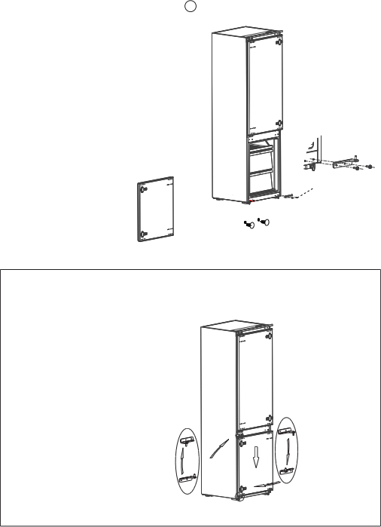
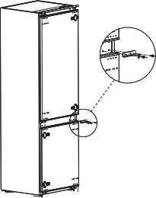
6 | Remove the the upper hinge of freezer door. | 7 | Remove the freezer door, the  bottom hinge and the hole caps.
F:
upper hinge

F:
 |  |  |  |  | bottom hinge
 |  |  |  | hole caps
8 Exchange the F:bottom hinge and F:upper hinge, then install them according to the following steps, and install the top hole cover and lower hole caps.

Install left
1
bottom hinge
Put the refrigerator door of left
2
bottom hinge vertically.
F:
upper hinge
Install left
3
upper hinge
2
3

F:
bottom hinge
CC266INT

10 The picture after completion is shown.
9
Remove the two fixed blocks of
freezer door and rotate them for
180°, and install them on other side of freezer door.

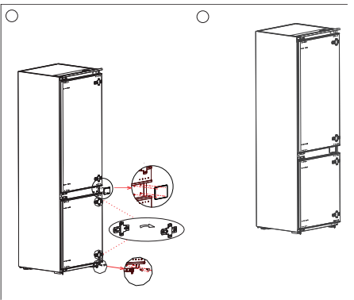

Hole cover

180

；‘’‘ Hole caps
CC266INT

3.CC400INT

3.1 CC400INT PRODUCT OVERVIEW

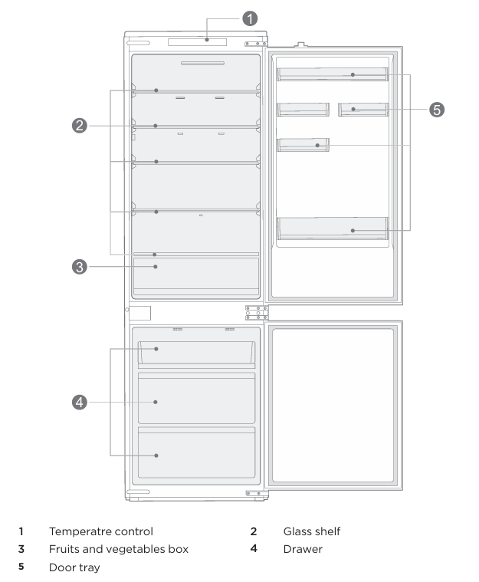
CC400INT

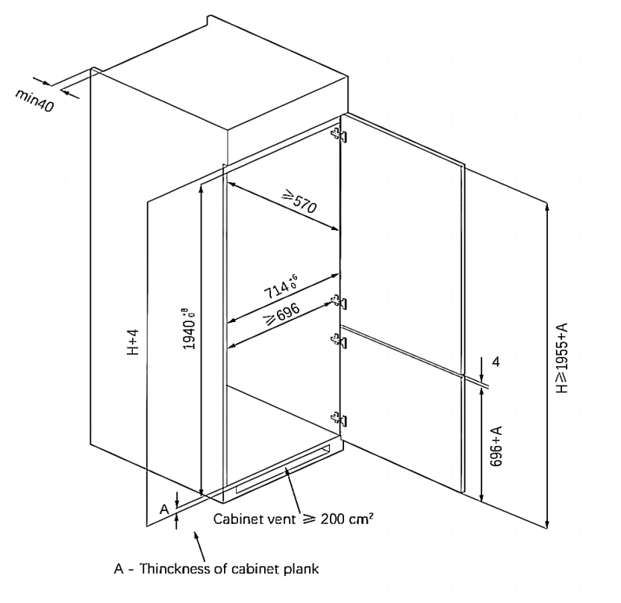
3.2 CC400INT-Cabinet preparation

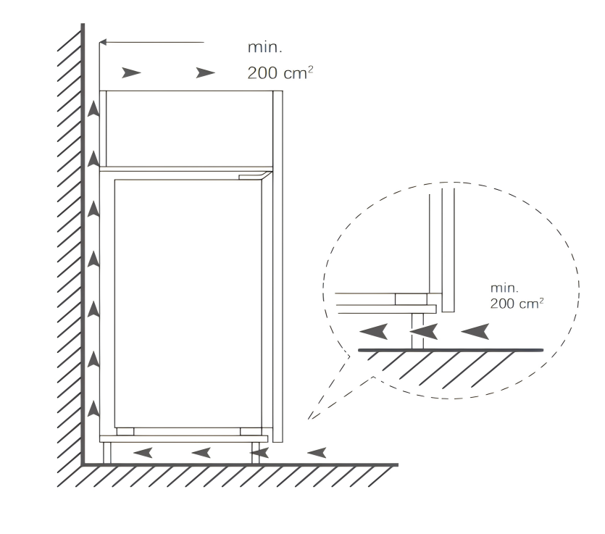
CC400INT

3.3 CC400INT-Installation

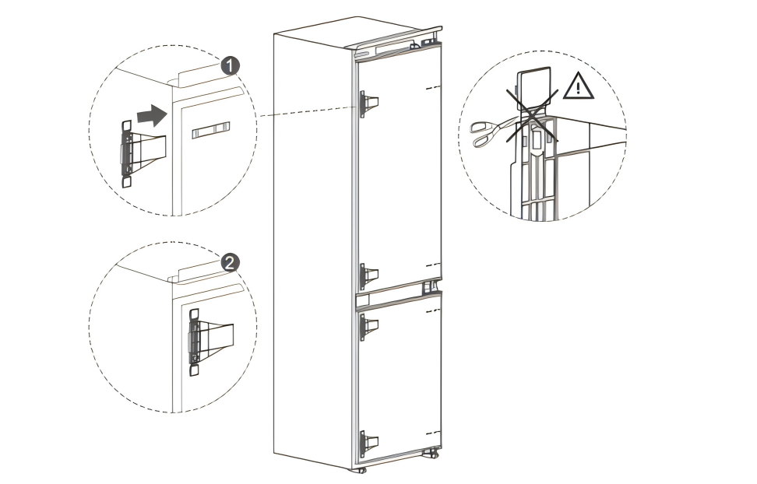
1.Install the four fixed blocks from the accessory package onto the sliding rails of the door body. Push the refrigerator into the cabinet and adjust it so that the top plate edges are flush with the cabinet’s top edge and the support leg hooks are firmly in contact with the cabinet’s bottom edge.
CC400INT

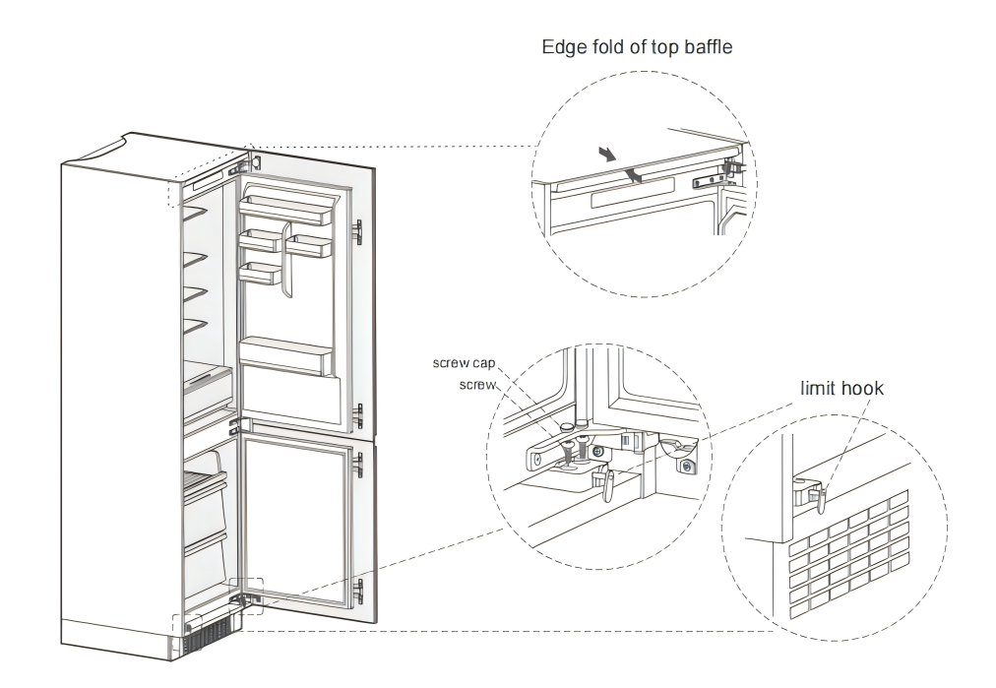
2.Fix the supporting leg with screws, then cover the screws with caps.

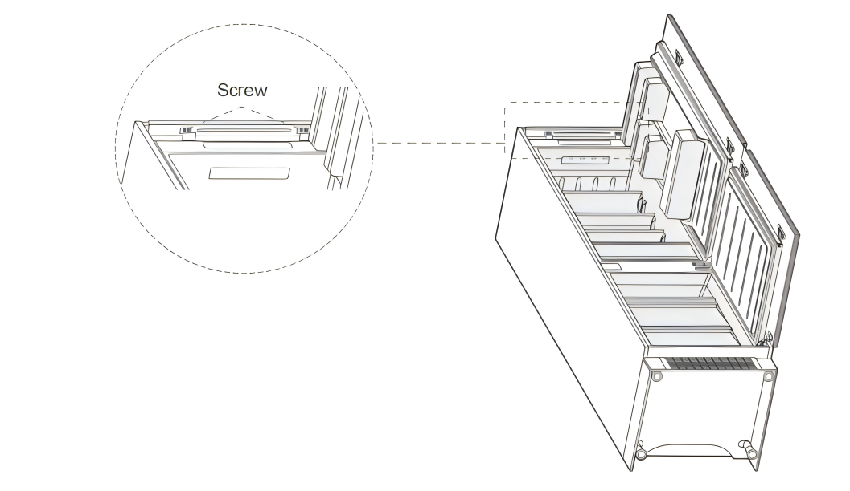
3.Fix the top baffle inside the cabinet with screws, then cover with
screw caps.

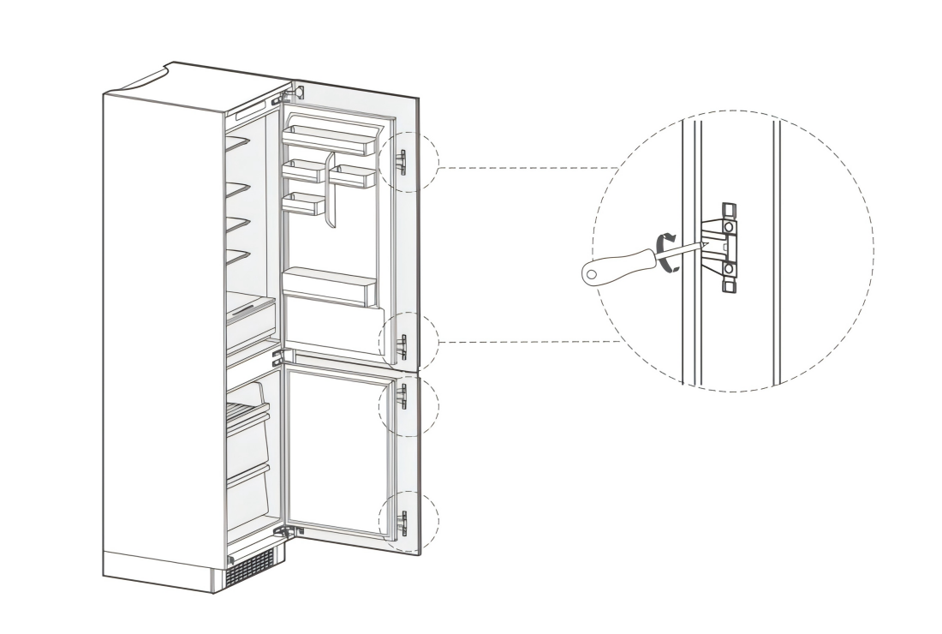
4.Open the lower cabinet door fully, then open the lower refrigerator door to the same position. Slide the alignment block until it aligns with the refrigerator door edge, secure it with screws, and cover with caps. Install the upper door in the same way. Finally, swap the adjustable foot and bottom hinge, then fix them securely.

5. Remove the sealing strip from the accessory bag and press it into the gap between the cabinet and the fridge.
CC400INT

4. CF304INT

4.1 CF304INT- PRODUCT OVERVIEW
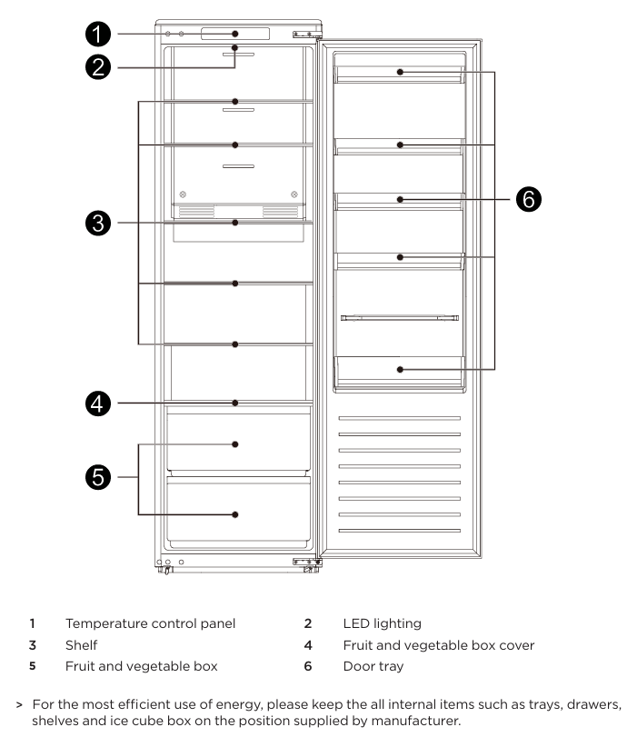
CF304INT

.
44.2 CF304INT-Cabinet preparation

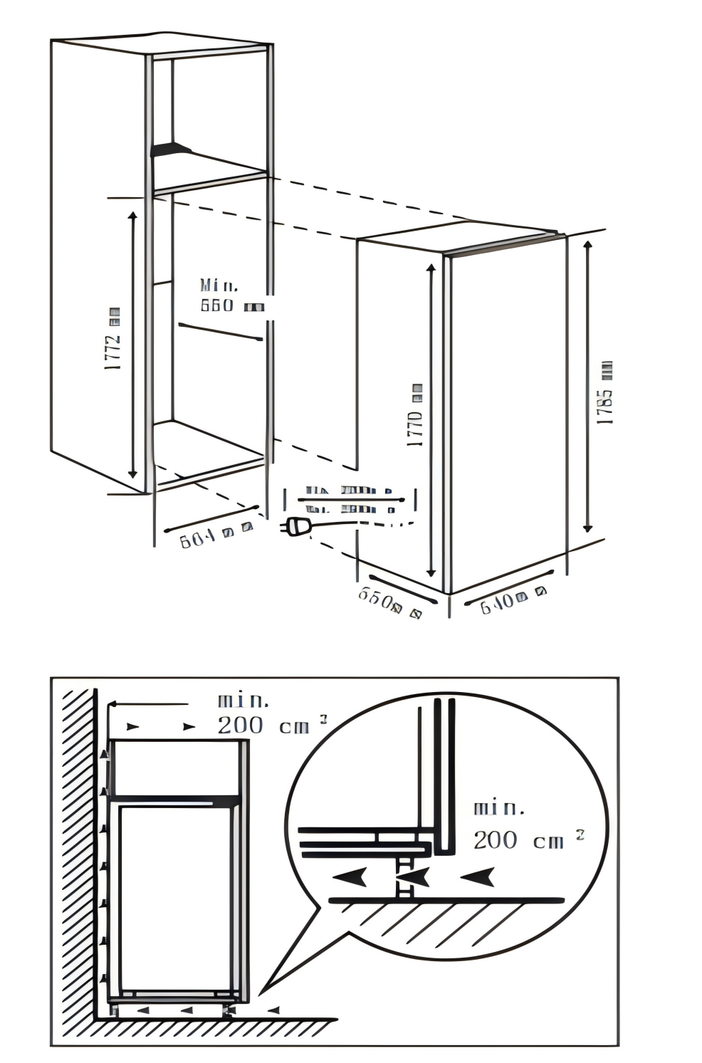
The skirting board and the back of the cabinet must have an open channel for heat dissipation.
570mm
CF304INT

4.3 CF304INT- Installation

1.Push the refrigerator into the cabinet and adjust it so the folded edge of the top baffle fully touches the cabinet’s top edge, and the supporting leg hook is firmly in contact with the cabinet’s bottom edge.
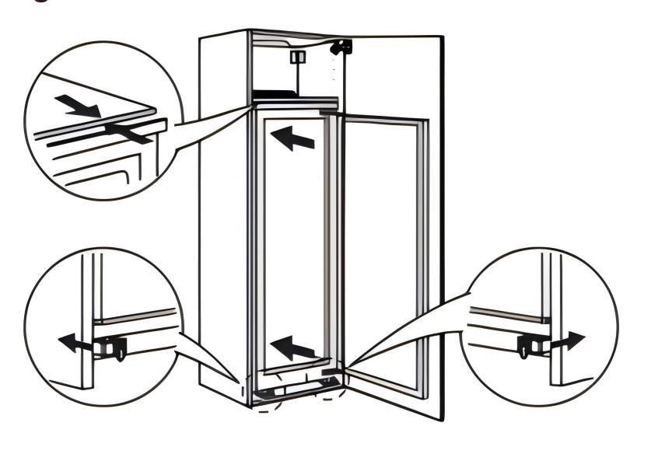

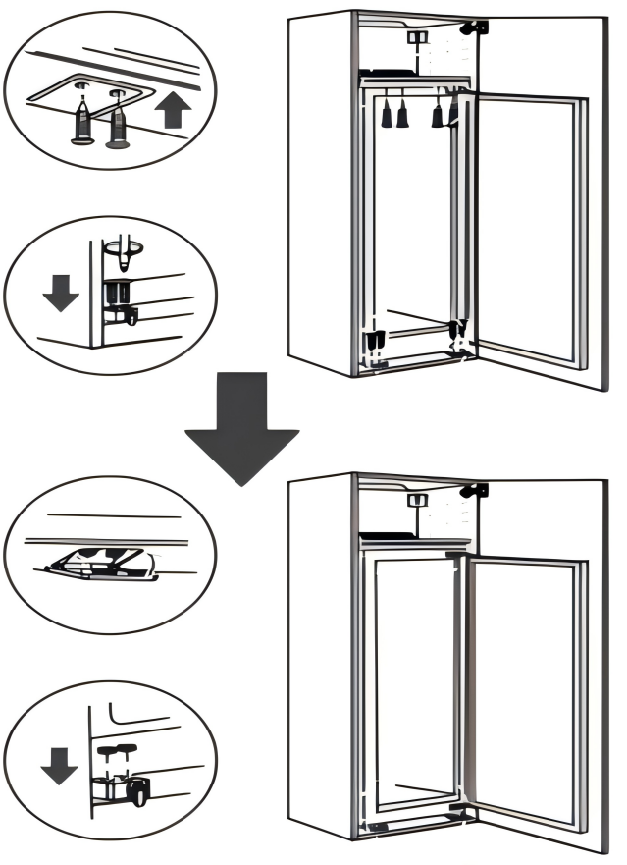
2.Fix the top baffle to the inside top of the cabinet with screws, then cover the screws with caps.
CF304INT

3.Open the cabinet door fully, then open the refrigerator door to the same position. Slide the alignment block until its inner edge aligns with the refrigerator door edge, secure it to the cabinet door with screws, and cover with screw caps.
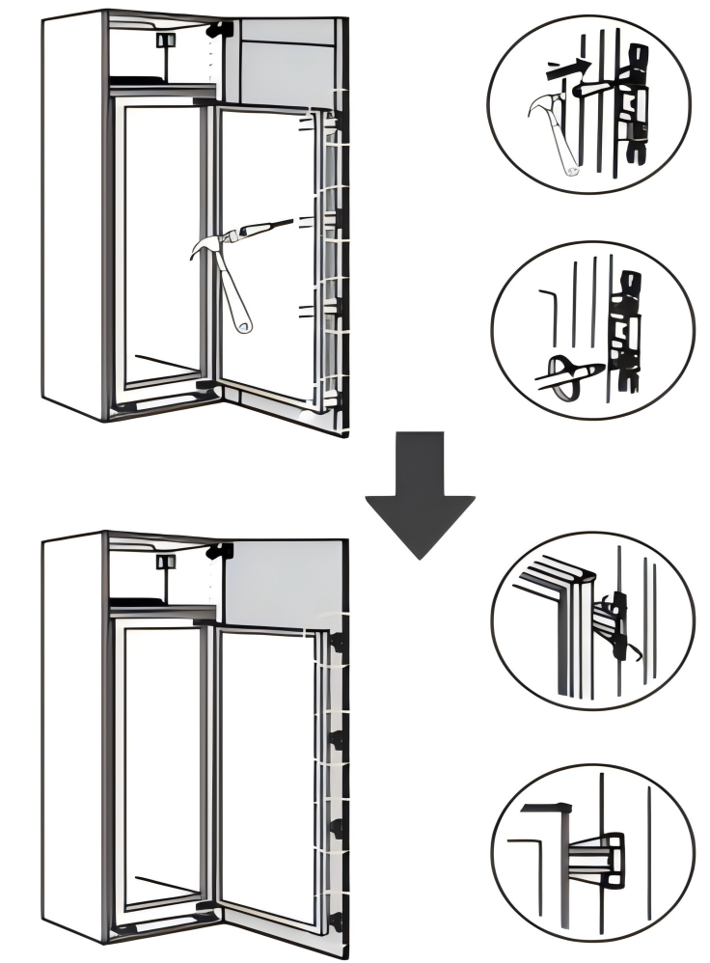

4.Remove the sealing strip from the accessory bag and press it firmly into the gap between the cabinet and the refrigerator. The installation is complete.
CF304INT

CF304INT

CF304INT

CF304INT

5.CZ212INT
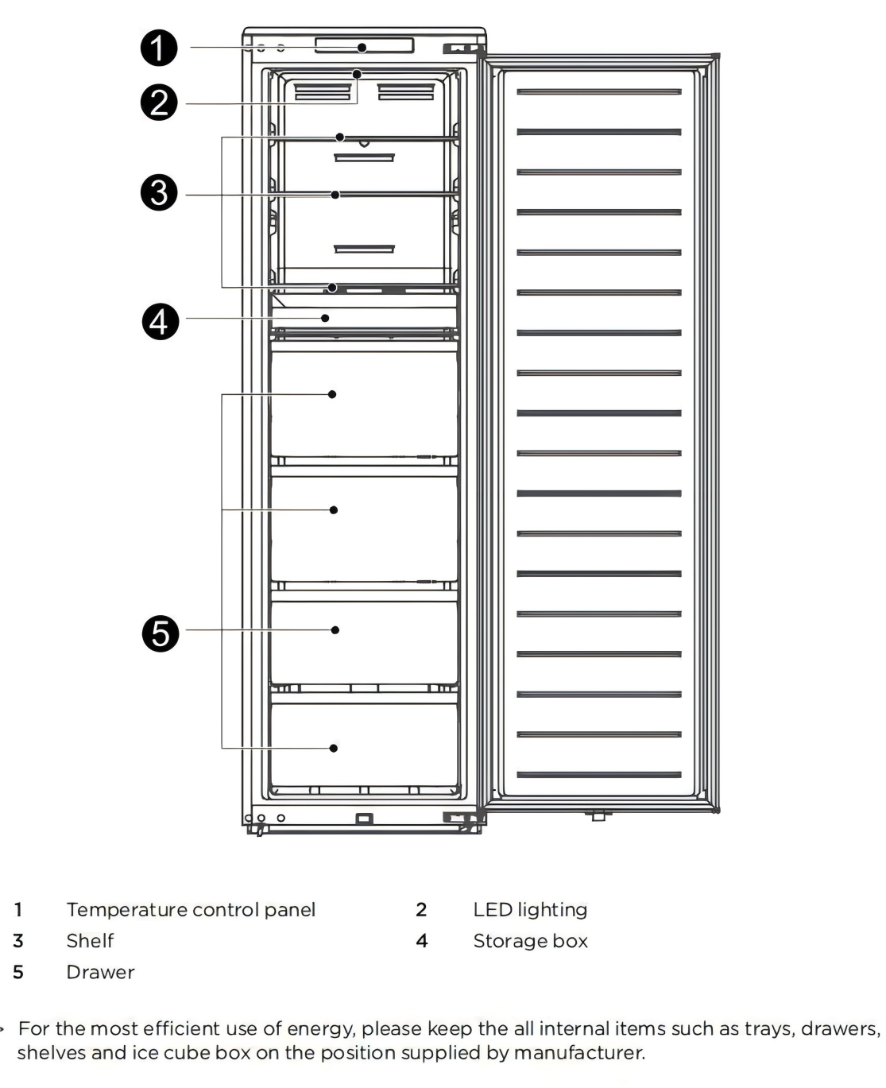
5.1 CZ212INT PRODUCT OVERVIEW
CZ212INT

5.2 CZ212INT-Cabinet preparation

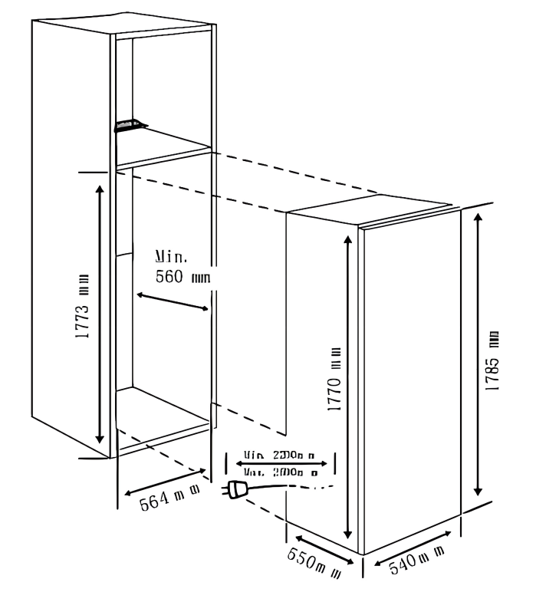
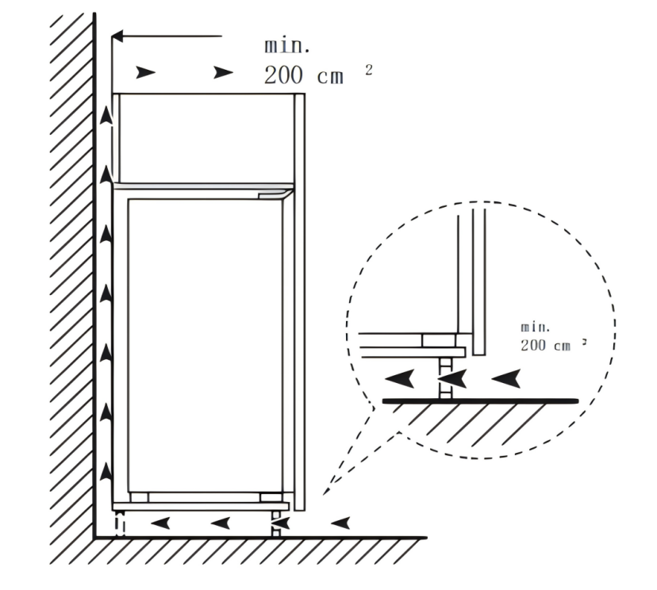
The skirting board and the back of the cabinet must have a continuous heat dissipation channel.
570mm
CZ212INT

4
5.3 CZ212INT- Installation

1.Push the refrigerator into the cabinet and adjust it so that the folded edge of the top baffle fully touches the cabinet’s top edge, and the supporting leg hook is firmly in contact with the cabinet’s bottom edge.
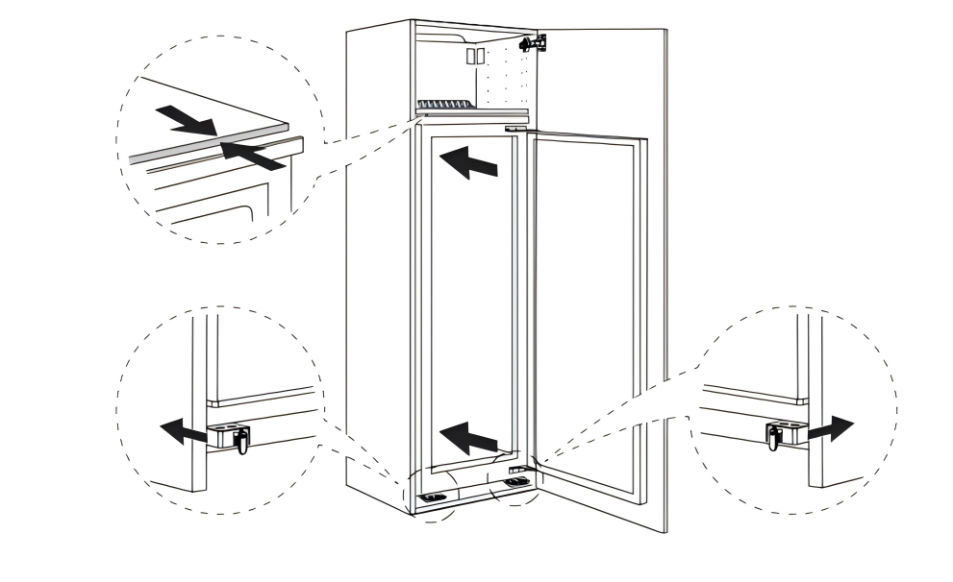
2.Fix the supporting leg with screws, then cover the screws with caps.

3.Fix the top baffle to the inside top of the cabinet with screws, then cover the screws with caps.
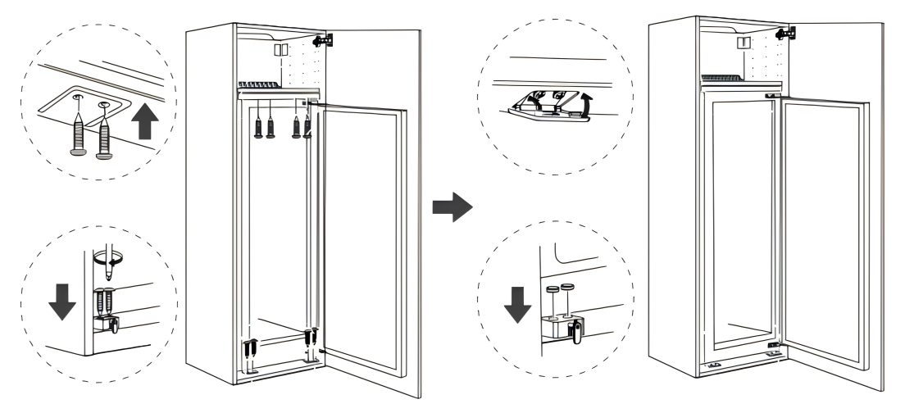

CZ212INT

4.Open the cabinet door to its maximum angle, then open the refrigerator door to the same position. Slide the alignment block until its inner edge aligns with the refrigerator door edge, secure it to the cabinet door with screws, and cover with screw caps.
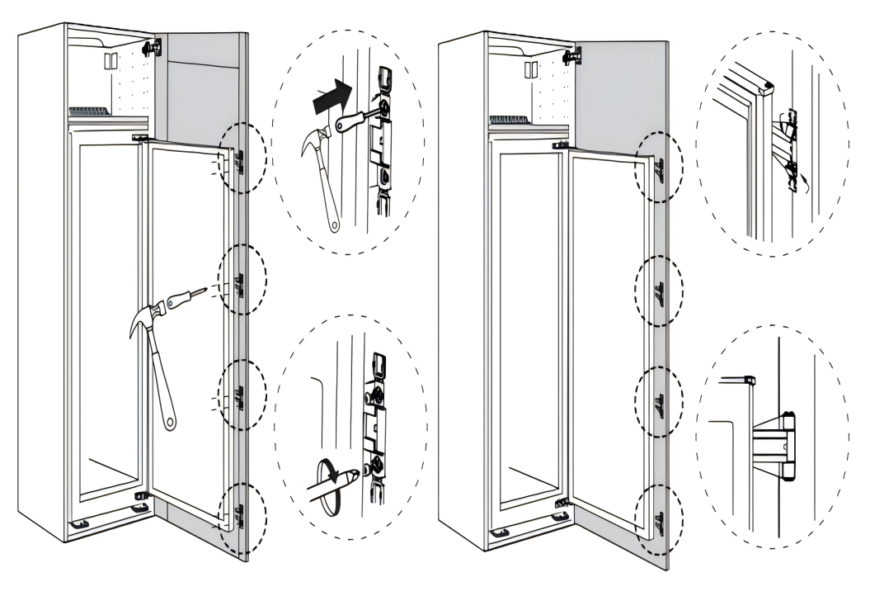

、

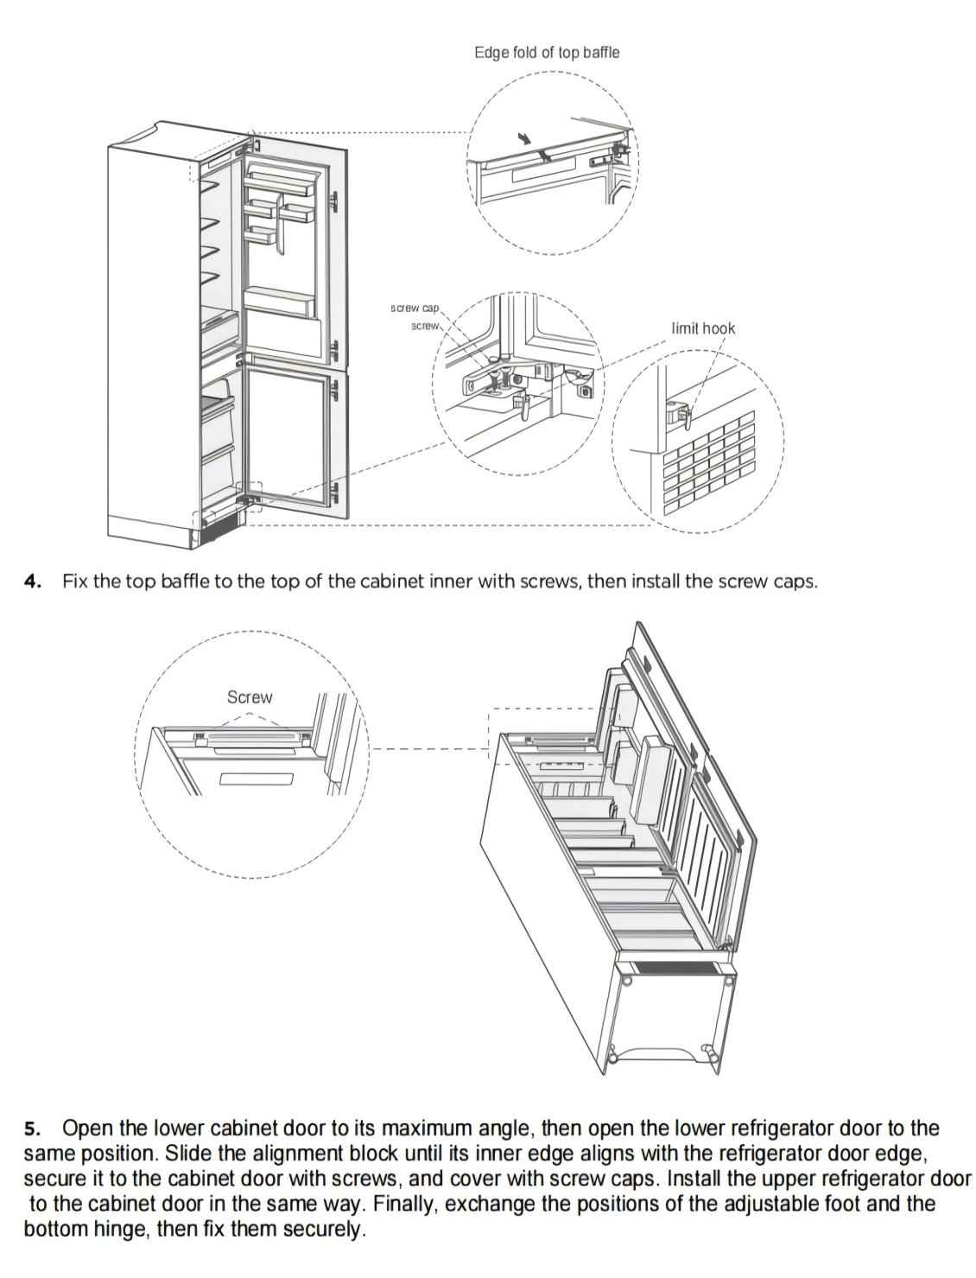
CZ212INT

CZ212INT

CC400INT

CC400INT

CC400INT

6. Using the Fridge & Freezer

6.1 Starting

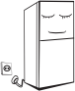

• Before the initial start, keep the refrigerator still for half an hour before connecting it to the power supply.
• Before putting any fresh or frozen foods in the refrigerator, the refrigerator shall run for 2-3 hours, or more than 4 hours in summer when the ambient temperature is high.
- ON/OFF, press “Standby/Unlock” and hold for 10s

6.2 Temperature Setting
- CC266INT
-Refrigerator Temp: +2°C to +8°C (default setting +4°C)
-To change setting, press “A” for 3s then select desired temperature.
-Freezer class: Four-star, temperature is –18°C and above.

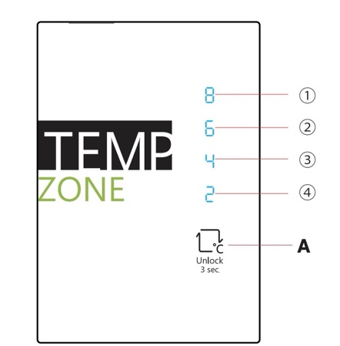


- CC400INT
-Fridge Temp: +2°C to +8°C (default setting +5°C)
-Freezer Temp: -16°C to -24°C (default setting -20°C)
-To change setting, press “” and or “” button repeatedly until
desired fridge or freezer temperature is selected.
-Press “” button to activate super cool mode (temp. +2°C) and it
will run for 6 hours, then exits automatically to last set temperature.
-Press “” button to activate super freezer (temp. -24°C) and it
will run for 40 hours, then exits automatically to last set temperature.
-Press “C” button for 3sec to activate “Vacation” mode. Freezer
temperature will be set to -20°C. To turn OFF, press again for 3sec.
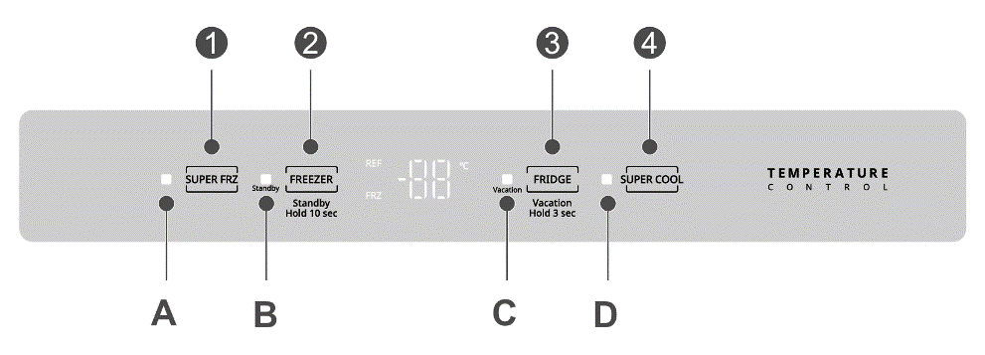

- CF304INT
-Fridge Temp: Cold (+8°C), Colder (+4°C), Coldest (+2°C),
and Super Cool
-To change setting, press “B” button repeatedly until desired
temperature is selected.
-Super Cool mode: Fridge will run at super cool setting for 6 hours
and will exit automatically to last set temperature.
-Default temperature setting: “Colder”.
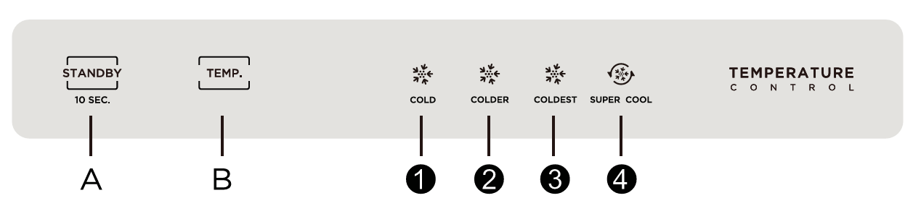
- CZ212INT
-Fridge Temp: Cold (+8°C), Colder (+4°C), Coldest (+2°C),
and Super Cool
-Freezer Temp: Cold (-16°C), Colder (-20°C), Coldest (-24°C),
and Super Freezer
-To switch setting between Fridge and Freezer, press “B” button for 3s
-When Freezer function is selected, freezer indicator “” is lit.
-To change setting, press “B” button repeatedly until desired
temperature is selected.
-Super Cool mode: Fridge will run at super cool setting for 6 hours
and will exit automatically to last set temperature.
-Supper Freezer mode: Freezer will run at super freezer setting for 6
hours and will exit automatically to last set temperature.
-Fridge/Freezer default setting: Colder
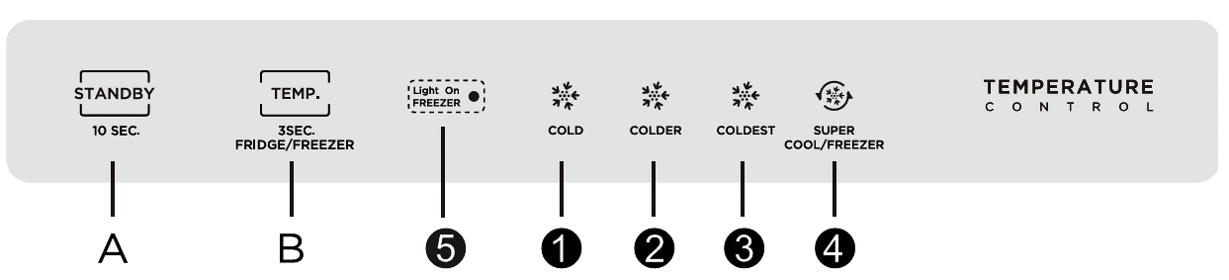

6.3) Lock/ Unlock
When the temperature control panel is in lock state, it needs to long-press the temperature setting key for 3 seconds to unlock the panel, all LEDs will blink for 2 seconds when panel is unlocked.
When the temperature control panel is in the unlock state, if there is no operation on the control panel within 30 seconds, it will automatically enter the lock state.
For models without Lock/Unlock function (CF304INT, CZ212INT), the settings will take effect 15 seconds after no operation.

6.4) Fault Display
In case of a failure, the corresponding LED blinks or error code is displayed.

- CC266INT
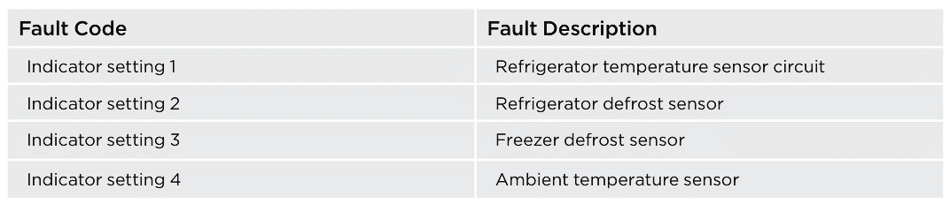

- CC400INT
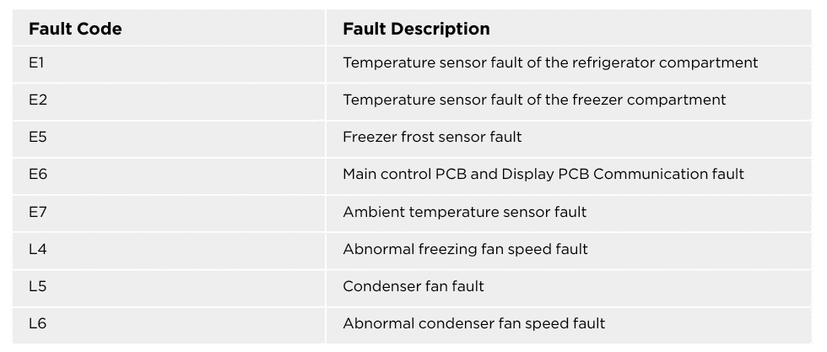

- CF304INT/CZ212INT
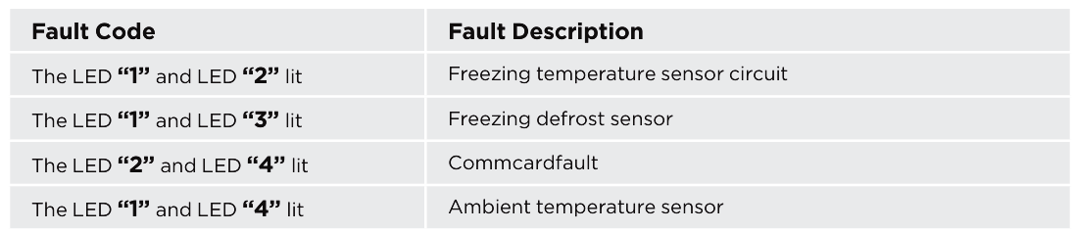

7. Warnings

7.1) Warning: Risk of Fire / Flammable Materials
Do not store explosive substances such as aerosol cans with flammable
propellants in this appliance

7.2) Warning: Intended Use
This appliance is intended for household and similar applications.

7.3) Warning: Vulnerable Users
This appliance is not intended for use by persons (including children) with
reduced physical, sensory, or mental capabilities, or a lack of experience
and knowledge, unless supervised or instructed by a responsible person.
Children must be supervised to ensure they do not play with the appliance.

7.4) Warning: Damaged Cord
If the supply cord is damaged, it must be replaced by the manufacturer, its
service agent, or similarly qualified personnel to avoid a hazard.

7.5) Warning: Unplug Before Maintenance
The appliance must be unplugged after use and before carrying out any
user maintenance.

7.6) Warning: Ventilation
Keep ventilation openings in the appliance enclosure or built-in structure
clear of obstructions.

7.7) Warning: Defrosting
Do not use mechanical devices or other means to accelerate the defrosting
process unless recommended by the manufacturer.

7.8) Warning: Refrigerant Circuit
Do not damage the refrigerant circuit.

7.9) Warning: Internal Electrical Devices
Do not use electrical appliances inside the food storage compartments
unless approved by the manufacturer.

7.10) Warning: Disposal
Dispose of the refrigerator according to local regulations, as it uses
flammable refrigerant and blowing gas.

7.11) Warning: Power Cord Position
When positioning the appliance, ensure the supply cord is not trapped or
damaged.

7.12) Warning: Power Sources
Do not place multiple portable socket-outlets or portable power supplies
behind the appliance. Do not use extension cords or ungrounded two-
prong adapters.

7.13) Warning: Child Entrapment Risk
Before discarding your old refrigerator or freezer, remove the doors and
leave the shelves in place to prevent children from climbing inside.

7.14) Warning: Electrical Disconnection
The refrigerator must be disconnected from the electrical supply before
installing any accessories.

8. Care & Maintenance
Unplug before cleaning
- Clean with mild detergent
- Wipe seals regularly
- Auto-defrost in fridge
- Defrost freezer if frost is ≥ 5 mm thick

9. Warranty & Support
Your Newmatic appliance includes a one-year warranty.
Website: https://newmatic.com/contact-us/
Email: info@newmatic.com

Scan for Delivery/ Installation/ Repair & Other Service

